

US Affiliate Sales Force
Targeting Methodology

Procedure Effective Date | 6-Feb-2007
Revision | Draft 0.1
Revision Effective Date | 30-Sep-2007

Revision History

Revision | Revision Date | Reason for Revision | Revised By
Draft | 30-Sep-07 | Creation | PM&T group

Table of Contents
1. Introduction 4
1.1. Purpose 4
1.2. Scope 4
1.3. Intended Audience 4
1.4. Givens Before Starting Analysis 4
2. Targeting Process – High Level View 5
3. Targeting Strategy 6
3.1. Inputs from Operations – MD universe to be used for targeting 6
3.2. Inputs from Brand Strategy - Key Player Segments 7
3.3. Targeting Algorithm 8
3.4. Specific Examples of Targeting Algorithms 11
3.5. Assessing the implications of the targeting algorithm 13
4. Targeting Implementation 15
5. Targeting Assessment 16
5.1. Planned vs Actual – National level 16
5.2. Planned vs Actual – Local level 17
5.3. Planned/Actual vs Optimal 17
6. Data Sources 19

- Introduction

  - Purpose
The purpose of this document is to describe the methodology behind the analysis done by USDS to support the different stages of the US Affiliate targeting strategy process. The details of the US Affiliate targeting strategy process can be found in the targeting SOP.

  - Scope
The scope of methodology is specific to products promoted by office based sleeves. The specialty products and institutional sales forces are out of scope for this document
Specifically, the methodology in this document is applicable to the following products and sleeves
Products
Cymbalta, Zyprexa, Strattera, Symbyax, Evista, Forteo, Humalog, Byetta, Cialis
Sleeves
NSPC, Psych Office, Osteo Specialty, Osteo PCP, Diabetes Health, Diabetes Care, Diabetes Focus, Novaquest NS, Novaquest Diabetes
  - Intended Audience
- Analytics person whose role is to do targeting analysis/assessment.
  - This document will help understand the methodology and know what data sources to use when creating the target list thus providing a starting point for the analytics person.
- This document can also be used by anybody else interested in better understanding the targeting methodology
  - Givens Before Starting Analysis
- Sleeve for which targeting needs to be done
- Number of territories and reps in the sleeve
- Products carried by the sleeve and the associated incentive weights
- Targeting Process – High Level View
A high level view of the targeting process is show in the figure below. A more detailed view can be found in the overall targeting process map.
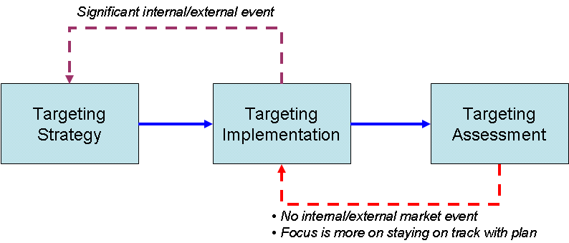

At a high level the targeting process consists of the following steps:
- Targeting strategy
  - Targeting Strategy is the process of translating brand strategy into actionable recommendation for the sales force.
  - The output of this step is a prioritization/tiering of MDs with associated call goals per MD.
- Targeting implementation
  - This step involves communication of targeting strategy to the field and sending out MD level lists by territory to the field.
- Targeting assessment
  - Targeting assessment measures the gap between recommended targeting plan and actual targeting implementation.
  - This provides the feedback loop to see if any changes need to be made to implementation
  - This is more relevant when there are no major external market events or internal events like change in sleeve focus and size and the focus is more on staying on track with planned targeting
  - A significant external/internal event would require revisiting the targeting strategy and redoing the targeting

- Targeting Strategy
Targeting strategy is the process of translating brand strategy into actionable recommendation for the sales force. The output of this step is a prioritization of MDs with associated call goals per MD. The prioritization of MDs is communicated to the reps by assigning tiers to MDs. Typically a maximum of 4 tiers are used with the order of importance going down from Tier 1 to Tier 4.
The specific steps involved in targeting strategy are:
- Taking inputs from operations on the universe of MDs that need to be used for targeting
- Taking inputs on key player segments from brand strategy for the brands carried by the sleeve
- Bringing together the key player segments for different brands carried by the sleeve and create relevant MD groups
- Perform valuation/prioritization of MD groups and group them into tiers
- Assign call goals per MD for different tiers
  - Inputs from Operations – MD universe to be used for targeting
The starting point of the targeting analytics is to determine the following from operations
- What is the MD universe under consideration?
- Which territories are they linked to?
- What is the planned head count in the territory?
- What is the territory hierarchy in terms of district, area, region?
The Lilly HCP universe are the MDs in the CRD database. Ideally the universe of MDs for targeting would be the MDs in ttp-quota file (Territory to Physician quota file) for the quarter for which targeting is being done. This is because these are the MDs based on which reps receive incentive payouts. There are challenges with using ttp-quota file due to timing issues. The ttp-quota file for a particular quarter is not finalized until the beginning of the quarter but the target lists needs to be sent to the field before the quarter begins. For targeting, one of the following two methods could be used to create the MD universe:
Method 1:
- Use the latest available ttp-quota file as the MD universe
- This is reasonable if reps are not expected to make too many changes in CDM and there are no large scale alignment changes in the works for the period for which targeting is done
Method 2:
- Operations agrees to a date by which all changes in CDM will be completed by the rep.
- The name, address, specialty of MD is obtained from CRD database which would incorporate all changes made by reps in CDM.
- The territory to MD map is obtained one of the following ways:
- Extracted from alignment ODS system that directly links MD to territory.
- Extracted using the zip to territory alignment for the quarter and the zip code of the MD address.
- The choice between the above ways to get territory to MD map depends on timing and would need to be done in consultation with data steward in incentives group and the contact in alignment group.
- The TTP specialty rules for the quarter of interest are used to identify MDs that shouldn’t be called on for a particular brand.
However, by the nature of the process there are possibilities of disconnect between the MD universe used for targeting and the MDs based on which incentive payouts are made. Also some of the MDs that may have moved to tier 5 by reps since they are deceased or retired may be put back in T1-4 in the lists generated by USDS. In the targeting process, these issues will be highlighted in the implementation guide to the field. A more detailed discussion on data flow and issues around defining MD universe can be found in targeting SOP.
There are multiple sources for getting territory hierarchy and head count but the different sources may not be synchronized depending on the timing. Depending on the situation, one data source might be more appropriate than another. Therefore it is critical to consult with data steward in incentives group, contact person in alignment group and the operations person to ensure that the right hierarchy and head count is being used. The possible data sources are alignment ODS system, zip to territory alignment, rep roster, operations input.
  - Inputs from Brand Strategy - Key Player Segments
Brand teams go through an extensive marketing planning process to set the brand strategy. One of the elements of the marketing planning process is the identification of key player segments and the key player objectives that need to be achieved with the segments to move the brand towards the intended positioning in the mind of the customer. Sales force is a tactic to achieve the key player objective with the different key player segments. Hence the key player segments from the marketing planning process is a key input to targeting strategy
While key player segments could be HCPs, Consumers or Payer for the brand, the key player segments of interest for targeting are HCP key player segments. The HCP segmentation varies by the product and life-cycle but most of the segmentation schemes involve some combination of following attributes of an MD
- Specialty (Psych, PCP, OBGYN etc.)
  - Data sources: CRD database
- Setting in which they practice (Office based, Institutional, LTC etc.)
  - Data sources : Rep laptop, MII Affiliation database
- Adoption propensity (Non-trier, Trier, Adopter etc.)
  - Data sources: IMS Xponent Rx data (US Answers)
- Attitudes (Attitudes towards disease state, products in the market)
  - Usually results from a LMR study on sample of MDs that is projected to the population by segmentation group within USDS which creates a MD level data with attitudinal segment assignments
- Volume of market/product Rx
  - Data sources: IMS Xponent Rx data (US Answers)
- Type of formulary access available for the product for each MD
  - Formulary/payer access metrics at MD level created by LMA group in USDS is available as MD level datasets
- Type of patients treated by MD
  - Data source: Anonymized patient level data that is a relatively newer data source
- Responsiveness of MDs
  - This would be from response models but is a relatively unexplored area and needed to be researched further
  - Targeting Algorithm
Targeting algorithms can be classified into the following two types
- Sequential rule based approach
- Simultaneous optimization approach
    - Sequential Rule Based Approach
This is the approach that has been used widely in Lilly and has been employed in recent targeting exercises for NS office, Osteo and Diabetes sleeves. This approach broadly follows the following sequence of steps:
Creation of MD groups that combine brand segments
Suppose 3 brands are being promoted by the sleeve and number of segments for brands 1, 2 and 3 are n1, n2 and n3 respectively, then there are potentially n1 x n2 x n3 groups of MDs. However, even if there are 3 segments per brand, this could result in 27 MD groups. Therefore these groups are further aggregated to form three or four groups. These groups are prioritized such that the MDs in tier 1 will be populated using MDs from highest priority group, MDs in tier 2 will be populated using group that is second in priority and so on to tier 4. The overarching goal behind creation of groups is to communicate clearly the identity of the group in terms of MDs that make up the group and why they are prioritized a particular way.
Prioritization of MDs within groups
The MDs in each group are prioritized using a combination of product Rx, market Rx, specialty, payer metrics, decile groups and other value metrics. The prioritization is used to add or remove MDs to ensure that the workload is within territory capacity
Creation of tiers and call goals by tier
The following two methods have been employed to create tiers and assign call goals by tier for each territory
Method 1:
- The number of MDs in each tier is fixed for all territories. Let the number of MDs in T1, T2, T3, T4 be n1, n2, n3, and n4 respectively.
- Pick n1 MDs from highest priority MD group and assign them to tier 1, n2 MDs from the next highest priority MD group and assign them to tier 2 and so on until tier 4.
- Call goal is set by sales operations using USDS analysis as one of the inputs
Method 2:
- All three or four MD groups that have been identified and prioritized are assigned tier 1-4 in order of priority
  - The will result in number of MDs in each tier varying by territories
- Assign call goals by tier such that the workload for the sleeve matches the sleeve capacity at national level
  - Call goal is set by sales operations using USDS analysis as one of the inputs
- At the territory level, there will still be mismatch between workload and capacity and therefore an additional step of tier smoothing to match territory workload is needed.
- The tier smoothing at territory level starts with the nationally assigned tiers and the MD prioritization within tiers.
- If the workload is more than territory capacity, MDs are moved down by 1 tier starting with movement from T3 to T4 followed by T2 to T3 and so on until workload matches capacity or no further movement is possible.
- If workload is less than territory capacity, MDs are moved up by 1 tier starting with movement from T2 to T1, T3 to T2 and so on until workload matches capacity or no further movement is possible.
- A variation of above method could be used if there are specific rules on whether MDs can be dropped from T1-4 in high workload territories or MDs can be added to T1-4 in low workload territories from a reserve pool of high value tier 5 MDs.
    - Simultaneous optimization approach
This approach is based on solving an optimization model that simultaneously determines the call goals by MD group, detail goals by brand that maximize total value while satisfying capacity constraints. Variants of this approach have been employed in other companies and were originally developed by Zoltners and Sinha in ZS Associates. The modeling framework is listed in their article on sales force design. This approach has not been used by Lilly in the recent past but is included as part of the documentation for the sake of completeness. Also a simplified version of the formulation is presented below for conveying the idea since the ZS formulation is for the whole nation across multiple time periods and takes into account the detail position in the call. However, extension of the formulation below to account for those is straightforward.
Optimization model formulation:
The inputs to the optimization model are:
- The set of MD groups (combination of brand segments) under consideration (indexed by g)
- The set of brands promoted by the sleeve (indexed by p)
- Maximum calls that a given MD in group g can receive from the sleeve – u_{g}
- Number of MDs in group g - N_{g}
- Details per call assumption for the sleeve - α
- Territory Capacity (# positions x call capacity per rep) - Cap
- Detail responsiveness of MD in group g to promotion of brand p – R_{ij}(d_{ij})
  - This indicates the valuation of the MD group for the particular brand and could be derived based on a combination of metrics such as response model estimates, market Rx, product Rx etc.
The decision variables of the optimization model are:
- Calls per MD to group g - c_{g}
- Details per MD for brand p to group g - d_{gp}
The objective of the optimization is determine the details per MD and calls per MD that maximizes value.
The constraints in the optimization are:
- Ensures that details per brand to not exceed the calls to the MD.
- Ensures that the calls per MD is less than the maximum calls per MD.
- Imposes the details per call constraint.
- Ensures that the total calls match the capacity of the territory.
- Ensures non-negativity of variables.
The mathematical formulation is provided below.

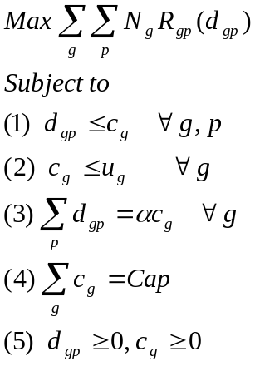

This method would involve solving a separate optimization problem for each territory. For example, for NSPC, this would involve solving about 500 optimizations. However each optimization will be smaller in scale and could be run using typical optimization solvers. Also, for targeting purpose the responsiveness function can be approximated as a piecewise linear function. If the function is assumed to be concave, then standard linear programming algorithms could be used to solve the problem. Some variations on the above problem would require the use of binary variables in the model. Some examples are using a S-shaped response curve instead of a concave curve or imposing that if a group is called on, then at least 3 calls must be delivered. The optimization would be harder if simultaneously national and local level constraints need to be satisfied. In such a case, the above optimization problem cannot be solved individually by territory but needs to be addressed as a large scale national level optimization problem.
Advantage of optimization approach over rule based sequential approach:
Once the optimization is run, the calls to each MD group can be used to prioritize groups and assign them to tiers. The call goals for the tiers would be the average calls per group making up the tier. This method automatically also gives the detail goals by brand for each tier. A separate step of matching capacity can also be eliminated.
Disadvantage of optimization approach over rule based sequential approach
While the optimization approach is conceptually elegant and simultaneously makes trade-offs on value for each brand versus territory capacity, the main disadvantage is that the tiering based on this may not be easy to communicate to the sales force. The type of MDs in the same tier but across territories could be quite different and that may cause confusion in the field. However, solving this optimization would still provide the optimal solution within the context of business rules and could be used to assess how far the proposed targeting scheme is from the optimal.
    - Other considerations before finalizing the targeting algorithm
The above targeting algorithm gives the idea behind the algorithms but each algorithm has certain details that are implementation specific and need to be incorporated before finalizing the algorithm. The rules for these are set based on discussions with operations. Below are some examples:
- How to treat MDs that overlap across sleeves?
  - Do we exclude them from one sleeve, or keep them in both sleeves with the same tier and call goal?
- How to treat MDs that are aligned to more than one territory?
  - Should the MD tier vary by territory or should it be constant?
- Are there certain MD groups that need to be treated differently such as NP/PA?

  - Specific Examples of Targeting Algorithms
This section has specific examples from targeting algorithms that have been used recently. These were based on the rule based sequential approach. The algorithms have been simplified to illustrate how the idea behind the algorithms follow the sequential rule based approach outlined above. As part of a targeting exercise, there are always sleeve/business unit specific details that are incorporated into the algorithm while working with operations that may not be captured in the overall approach.
    - Example: NS Office Psych
Givens for the analysis:
NS Office Psych promotes Cymbalta (MDD/DPNP), Zyprexa, Strattera and Symbyax. Symbyax was not specifically targeted by the sleeve and hence excluded from the analysis.
Input from operations – MD universe:
Method 2 (refer to section on input from operations) was used for getting MD universe. This is because reps were asked to make any changes that was necessary in their territories in CDM by March 30,2007. Therefore, the CRD and Alignment ODS data was pulled as of April 1, 2007 for the targeting exercise. The CQ2’07 (Calender Q2’07 – same as Fiscal Q3’07 FQ3’07) ttp specialty rules were applied to the CRD MD list. An additional criteria imposed was that only T1-4 MDs in laptop would be considered in the analysis. Because of this constraint, this was a retiering exercise instead of a retargeting exercise. However, the steps and the work involved are still the same as a retargeting exercise.
Input from brand strategy – Key Player Segments
The key player segments for Cymbalta (MDD/DPNP), Zyprexa, Strattera are based on specialty
- Cymbalta MDD – Psychs and PCPs in ADP 3-10
- Cymbalta DPNP – Anesthesiologist, Pain Specialties and Neurologists
- Zyprexa – Psychs and PCPs
- Strattera – Psychs, PCPs and Peds
The PCP key player segments are not relevant for NS Office Psych targeting since they are covered by NSPC sleeve. While the brand key player segments are at the specialty level, a more granular brand segmentation is used for targeting by using the additional dimension of decile groups. For targeting, the brand segments used are:
- Cymbalta MDD – Psych ADP 7-10, ADP 3-6
- Cymbalta DPNP – It was decided to treat this as a single segment
- Zyprexa – Psych APS 7-10, APS 3-6, APS 1-2 (Zypx 2-10)
- Strattera – Psych ADD 7-10, ADD 3-6
Creation of MD groups that combine brand segments
Based on above brand segments, the number of possible MD groups are 12 (2x1x3x2). However, the maximum number of tiers is 4. So the above brand segments were combined into the following MD groups:
- High ADP or APS writers - ADP 7-10 OR (APS 7-10, Zypx 1-10)
- Medium ADP or APS writers - ADP 3-6 AND (APS 3-6, Zypx 1-10)
- DPNP MDs
- Rest of brand targets
This assignment of tiers was chosen since the tier clearly communicated the type of MDs in the tier.
Prioritization of MDs within groups
Non DPNP MDs were prioritized based on the following metrics:
  - Priority 1 – Weighted combination of ADP, APS, ADD decile based on incentive weights
  - Priority 2 – ADP decile
  - Priority 3 – APS decile
  - Priority 4 – ADD decile
  - Priority 5 – NS office calls in Q1’07
  - Priority 6 – NS account calls in Q1’07 (for NS Psych)
DPNP MDs were not prioritized since all of them were targets
Creation of tiers and call goals by tier
Method 2 (see section on creation of tiers) was used in this instance where the MD groups were assigned to tiers 1-4 as follows at the national level:
- High ADP or APS writers – Tier 1 (Call goal – 12 per qtr)
- Medium ADP or APS writers – Tier 2 (Call goal – 9 per qtr)
- DPNP MDs – Tier 3 (Call goal – 6 per qtr)
- Rest of brand targets – Tier 4 (3 per qtr)
This assignment of tiers at the national level was chosen since the tier clearly communicated the type of MDs intended to be in the tier. However since this would result in capacity imbalance at the territory level, tier smoothing was done at the territory level using MD prioritization rules and the methodology described in method 2 (see section on creation of tiers) to match capacity. Even after tier smoothing, there would be some territories that are over or under capacity but would be much less and handled on an individual basis by operations. The NSPC and Psych Office presentation on targeting algorithm has the complete details of the targeting algorithm used for the retiering exercise.
    - Example: Osteo PC
Givens for the analysis:
Osteo PC promotes Evista and Forteo.
Input from operations – MD universe
A custom database with MD to territory link to be used for targeting was provided to USDS
Input from brand strategy – key player segments
The key players relevant to the sleeve are:
- Evista – OBG and PCP
- Forteo - Excludes IM in Forteo 3-10 and Endos/Rheums
For targeting, the segments are further broken out using decile groups and payer access quantiles.
- Evista – Specialty (OBG, PCP), Bone decile (High, Medium, Low), Evista decile (High, Medium, Low)
- Forteo – Forteo writer - Forteo decile (High, Low), Forteo Non Trier (Payer access quantile)
Creation of MD groups that combine brand segments
The above brand segments were combined into the following MD groups:
- High Bone Customers – Priority 1
- High Forteo Customers that are not High Bone Customers – Priority 2
- Low Forteo and Medium/Low Bone Customers – Priority 3
- Forteo non-writers and medium Evista writers – Priority 4
Prioritization of MDs within groups
- High Bone Customers
  - Priority 1 : Specialty (OBG followed by PCP)
  - Priority 2: Bone decile
  - Priority 3: Inverse HRT decile
- High Forteo Customers that are not High Bone Customers
  - Priority 1: Forteo decile
  - Priority 2: Bone decile
- Low Forteo and Medium/Low Bone Customers – Priority 3
  - Priority 1: Evista decile
  - Priority 2: Forteo decile
  - Priority 3: Bone decile
- Forteo non-writers and medium Evista writers – Priority 4
  - Priority 1: Evista decile
  - Priority 2: Forteo payer access quartile
  - Priority 3: Bone decile
Creation of tiers and call goals by tier
Method 1 (see section on creation of tiers) was used to tier MDs where tiers were defined as follows:
- Tier 1 – Top 15 MDs in high bone customers group (Call goal -6 calls/qtr)
- Tier 2 – Top 5 MDs in high Forteo customers but no high bone customers group (Call goal – 9 calls per qtr)
- Tier 3 – Top 45 MDs in low Forteo and Medium/Low bone customers group (Call goal – 6 calls/qtr)
- Tier 4 – Top 25 MDs in Forteo non-writers and medium Evista writers group (Call goal – 3 calls/qtr)
Therefore each territory has 90 MDs. The Orion algorithm presentation has the complete details of the targeting algorithm for Osteo PCP and Osteo Specialty sleeves. The Sunflower algorithm presentation has the complete details of the targeting algorithm for Diabetes Health, Diabetes Care, Diabetes Focus, and NQ Diabetes sleeves.
  - Assessing the implications of the targeting algorithm
A key step before implementation is to assess the implications of the targeting algorithm in terms of coverage of key players across brands and the matching of call goals with capacity of sleeve. The logic behind the targeting algorithm and the implications of the targeting algorithm are presented to Operations and Senior Management to get the go ahead on implementation.
The implications of the targeting algorithm are determined by evaluating the following:
- How many MDs are there in each tier?
  - How does the new tiering recommendation compare with the previous tiering?
  - If a national tiering is followed by tier smoothing at the territory level, it would be of interest to cross-tabulate the amount of shift between national tier and territory tiers.
- How many calls are expected to be delivered in each tier and by the entire sleeve?
- How well are the brand key player segments covered both in terms of MDs and in terms of potential?
  - This is done by cross-tabulating the MD tier with MD key player segment for the brand to see how the brand key player segments fall out by tier and how much of the brand potential is covered in each tier. An example from NS retiering is listed below. The tables below show that of the 14K Cymbalta MDD targets in Psych Ofc sleeve, 12K are in tiers 1 and 2 and account for 89% of the potential of all targets in the sleeve.
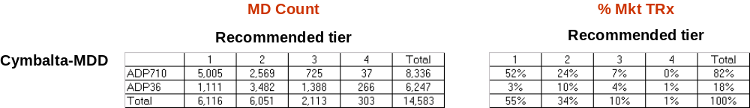

- What is the overlap between key player segments for different brands?
  - Some key player segment overlaps across brands may have been used to define the MD groups and tiers. But in some cases while certain key player segments may not have driven the definition of MD groups/tiers, it is of interest to see after the fact the amount of overlap they may have. For example, in Psych Ofc sleeve, the Strattera key player segments were not explicitly used to define T1-2 MDs but after the tiering, it was of interest to check the number of Strattera key players in T1-2.
These constitute what will occur if targeting is done as planned. Targeting assessment is the step where the actual targeting by the field is compared with the planned targeting. Further examples of the type of outputs used in assessing the implications of targeting are available in the NSPC and Psych Office retiering presentation
- Targeting Implementation
This step involves communication of targeting strategy to the field and sending out MD level lists by territory to the field. Most of implementation related tasks are done by operations. The role of USDS in this phase is to send out the MD level lists by territory in a format specified by operations. Mostly the following two formats have been used in the past:
- Excel files that contain MD level lists by territory and fields specified by operations.
  - Typically a separate excel file is created for each sleeve
  - These are posted in KM by operations to be accessed by reps
  - Reps use this list to manually change the tiers in their respective laptops
  - The field that are typically contained in this file are:
    - MD identifier (Lilly personid, IMS affiliation id, affiliation source)
    - MD profile (IMS specialty, Lilly Specialty)
    - MD name and address
    - Territory, District, Area, Region names and IDs
    - Rx/decile/value information relevant to the tiering scheme
    - Tier information of other sleeves that coordinate with a given sleeve and any prior tier information
  - Click here to view the Psych Office listed posted to KM in May’07
- Push the list with tier information directly to laptop through IT
  - In this case, a text file containing tier information in a format specified by IT is sent to IT to be pushed to laptop
  - There is not much flexibility in adding additional fields in this list
  - Therefore even when the list is pushed through IT, the excel files are still posted on KM since the additional field in excel file help communicate the logic of the tiering to the rep
  - Click here to view IT format guidelines (as of Jan’06) and click here to view sample records of a target list sent to IT to be pushed into the laptop.
  - It is suggested to contact IT to check on the latest format guidelines before creating the list for IT.

- Targeting Assessment
Targeting assessment is a vehicle to determine whether any changes need to be made to targeting implementation. Targeting assessment measures the gap between recommended targeting plan and actual targeting implementation. Depending on the gap between plan and actual, targeting changes could range from minor geographic tweaks on one end to full scale retargeting on the other end. The implicit assumption when starting a targeting assessment is that no significant market events/internal events have occurred that have implications on brand strategy. Significant market events might include competitor launch, label change, competitor product withdrawal. Significant internal events include change in sleeve headcount and sleeve focus. If a significant market event/internal event has occurred, there is no need for targeting assessment since the nature of the event would automatically trigger revisiting the targeting strategy and do a retargeting. Targeting assessment is relevant more in instances in the absence of significant market/internal events and any changes are more due to drift of MDs between deciles and segments. In this case, the planned targeting is still relevant and the focus is on identifying gaps in implementation and this can be done using targeting assessment. The targeting assessment analysis consists of the following three parts:
- Comparison of planned vs actual targeting at the national level
- Comparison of planned vs actual targeting at the local level (Area, district, territory)
- Comparison of planned and actual to optimal level of targeting
Each of the steps is explained in more detail in the subsequent sections. The complete details can be accessed by clicking on the following links for NSBU, DBU, and Osteo presentations on targeting assessment.

  - Planned vs Actual – National level
In the national level view, the following types of analysis are reviewed:
Comparison of planned vs actual coverage of brand key player segments
This would be done for each brand that is covered by the sleeve
An illustrative example is given below
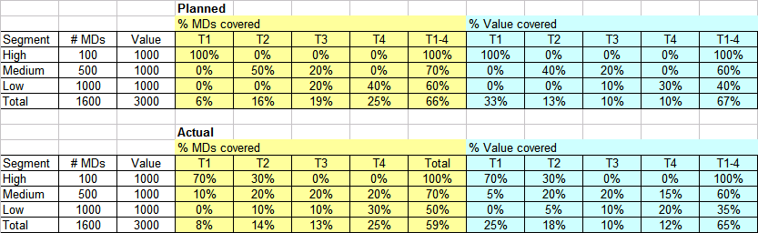
Based on the above table the following inferences can be made:
- The actual coverage of key players (59%) is less than planned by 7%.
- The actual value covered, however, is similar to planned coverage of value (65% vs 67%)
- 30% of high value customers have been moved to T2 from T1
Comparison of planned vs actual tiering of MDs in the sleeve
An illustrative example is given below:
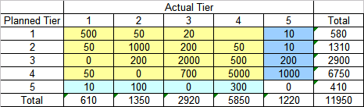
Some of the questions that can be answered based on the above table are:
- The planned T1-4 MDs is 11,540 and the actual T1-4 MDs are 10,730
- 1220 MDs that were have been moved from planned T1-4 to T5.
- 410 MDs that were not in planned T1-4 have been added to T1-4
- Of the MDs that are in planned and actual T1-4, 82% have not been retiered by the rep
Review of distribution of calls per MD by tier and comparison of planned vs actual total calls by the sleeve
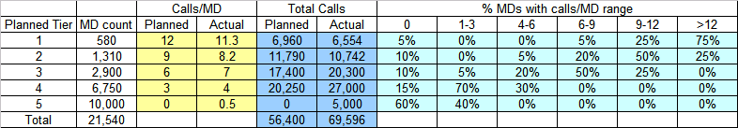
This table shows that:
- The average calls/MD is slightly below the goal for T1-2 and slightly above for T3-4.
- However, the total actual calls is higher than the total planned calls with about 5K calls on MDs that were not planned to be in T1-4
- The table also shows the distribution of calls per MD in each tier and show % of MD that have not been reached in each tier
  - Planned vs Actual – Local level
Once the gaps between actual and planned targeting are determined at the national level, a drill down analysis is done at the Area, district, territory level to see the distribution of gap between planned and actual across geographies. This will help determine outlying geographies or indicate that there is a gap across all geographies.
The type of outputs from this analysis would involved histograms/tables. Currently it is in the presented in power point slide format but the ideal method would be a tool that is interactive. Some examples of the type of outputs are listed below:
- Distribution of % Actual calls/call goal
- Distribution of % coverage (#MDs and TRx) of different brand key player segments
- Distribution of % MDs retiered
  - Planned/Actual vs Optimal
Optimization based targeting algorithm discussed in the targeting strategy section can be used to estimate the optimal achievable plan and can be compared with planned and actual targeting. This implies that the optimal is not the unconstrained optimal solution but constrained based on sleeve headcount and territory level mix of brand key player segments. These three scenarios could be overlaid on the incremental revenue/contribution curve to view it in the broader context. An illustrative example is shown below that shows the incremental revenue/contribution curve for each brand with the points representing planned, actual, and optimal details for the brand on the curve. The planned details by brand may need to be estimated since typically targeting plan includes only call goals and not detail goals. One option is to use the call plan details as the planned details. The example below shows that:
While actual details are more than planned details, they are not as efficiently delivered and hence result in a lower 3 year incremental revenue.
There is not a significant difference in 3 year incremental revenue between planned, actual and optimal and hence it is not necessary to make any change in targeting
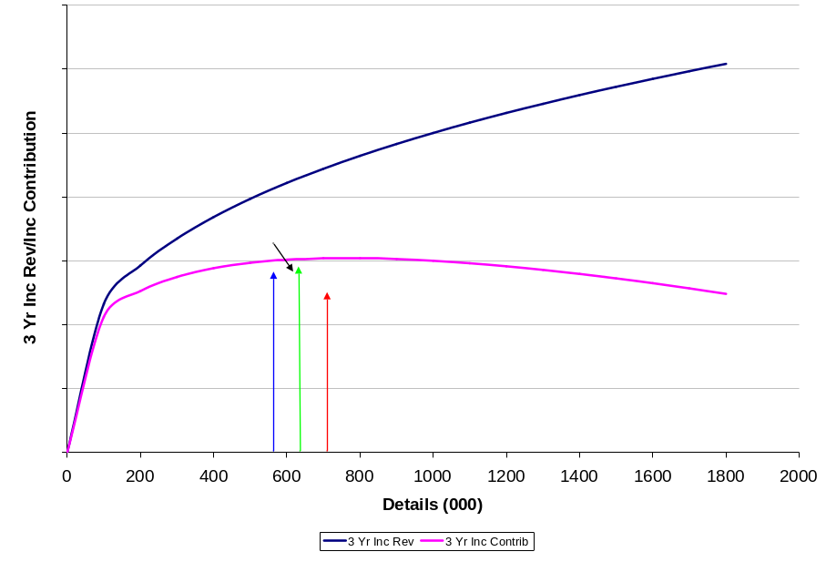

- Data Sources
The data sources used in the different stage of targeting analytics can be broadly classified into the following buckets:
- HCP profile data – CRD database
  - MD identifier, name, address, specialty (IMS/Lilly)
  - The CRD database feeds US Answers but the data in US Answers is refreshed only monthly whereas the CRD database is refreshed daily
- HCP script based data – US Answers
  - Based on IMS Xponent/Plantrack data
- HCP segment data
  - These might be segments derived based on Rx data or other valuation metrics such as patient data/responsiveness data/attitudinal data
- HCP quota data – Incentives group/IT
  - This is the database of MDs that are in the quota pool for a given territory.
- Sales rep activity data – (Dendrite transitioning to US Answers)
  - This is the activity (Details/samples/programs) recorded by reps in Premier Force currently captured in Dendrite/US Answers.
  - This is the source of MDs tiered up in laptops of reps.
Since it is more time consuming to always go to the original data source, USDS has a data warehouse AW.PAR that houses most of the information from the above data sources. The specific databases that may need to be used at the different phases of targeting is listed below:
Input from Operations – MD universe to be used for targeting
- Method 1 universe:
  - MD territory link from quota file: qta.ttp_profile_<qtr of interest>
    - Ensure that the appropriate MDs are pulled for specific therapeutic class codes
    - For example, a PED would be in ADD quota but not in ADP quota
- Method 2 universe:
  - MD territory link from alignment ODS: pds_cstmr_srs
  - Zip to Territory File: Typically a text file from the contact person in Alignments group
  - MD address information if MD zip code is used to assign territory:
  - par.customer_<date> - Use this if monthly refresh timing is not an issue
  - crd_hcp_data_service, crd_hcp_address_data_service (need access to CRD database to get this)
    - Use this if data needs to reflect information latest as of previous business day
- Territory Hierarchy and head count – possible sources
  - Alignment ODS – pds_trtry_hrchy
  - Zip to Territory File
  - Rep Roster from HR
  - Input data from operations
- Laptop tier information
- This is used if there is additional criteria for MD universe based on current tiering in laptops
- MD directory laptop pulls can be used to get this: md.laptop_pull_<sleeve>_<date>
Sometimes the different systems are not synchronized and therefore some manual checks and consulting with data steward in Incentives group, contact person in alignment group and operations person would be needed to ensure that the right territory hierarchy and head count is feeding into the targeting analytics.
Input from brand (Key player segments), MD grouping and prioritization
This step uses value metrics that feed into segmentation/grouping/prioritization. The value metrics are typically based on product/market Rx volume, product adoption, specialty. However, newer data sources on patient level data would probably find increasing use in future targeting exercises.
- Product/Market Rx volume and adoption data:
  - This can be extracted directly from or estimated based on data from the following PAR datasets:
    - Par.<mkt>_rx_<date>
    - Par.decile_<date>
- Specialty:
  - This would be available from the dataset created for the MD universe
These cover most of the data sources that have been used in the recent targeting exercises.

